Carbon Reduction Plan
Supplier name: Focusmed24 Limited
Publication date: 09/01/2023

Commitment to achieving Net Zero

Focusmed24 Ltd is committed to achieving Net Zero emissions by 2035.

Baseline Emissions Footprint
Baseline emissions are a record of the greenhouse gases that have been produced in the past and were produced prior to the introduction of any strategies to reduce emissions. Baseline emissions are the reference point against which emissions reduction can be measured.

Baseline Year: 2022
Additional Details relating to the Baseline Emissions calculations.
This is our first Carbon Reduction Plan so we have no historical figures to compare.
Baseline year emissions:
EMISSIONS | TOTAL (tCO2e)
Scope 1
Scope 2
Scope 3
(Included Sources)
Total Emissions

Current Emissions Reporting
Reporting Year: 2022/2023
EMISSIONS | TOTAL (tCO2e)
Scope 1 | Zero
Scope 2 | 1.7 tCo2
Scope 3  (Included Sources) | Category 4 Zero, rationale detailed below.  Category 5 0.02tCo2.  Category 6 Zero, rationale detailed below.  Category 7 0.1tCo2.  Category 9 Zero, rationale detailed below
Total Emissions | 1.82 tCo2

Emissions reduction targets
Scope 1
We are in managed offices.
Company Vehicles: we do not have any company vehicles, so there are no emissions from this category included in our emissions data.
Scope 2
Purchased electricity, steam, heating and cooling for own use.
Scope 3
Category 4 and 9
We are an administration-based business, we do not purchase or sell any goods, so we can't report any figures against categories 4 and 9.
Category 5
Office waste generated and disposed of.
Category 6
No business travel.
Category 7
Employee commuting: 3 members of office staff, one cycles, one walks and one drives 2 miles 3 times a week.

In order to continue our progress to achieving Net Zero, we have adopted the following carbon reduction targets.

We project that carbon emissions will decrease over the next five years to 1.4 tCO2e by 2027. This is a reduction of 24%

Progress against these targets can be seen in the graph below:

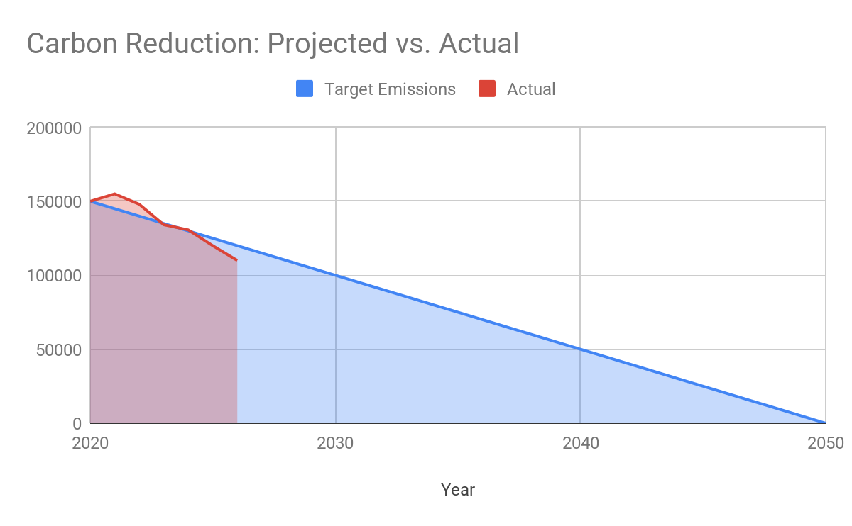

Carbon Reduction Projects

Completed Carbon Reduction Initiatives
We are now looking at ways to reduce our emissions for the coming 5 years as this is our first CRP.

In the future the one member of staff that drives in will begin to walk or cycle to work saving on fuel emissions.

Our waste paper will be taken to a recycling centre by us reducing the waste disposal via the external company.

Declaration and Sign Off
This Carbon Reduction Plan has been completed in accordance with PPN 06/21 and associated guidance and reporting standard for Carbon Reduction Plans.
Emissions have been reported and recorded in accordance with the published reporting standard for Carbon Reduction Plans and the GHG Reporting Protocol corporate standard and uses the appropriate Government emission conversion factors for greenhouse gas company reporting.
Scope 1 and Scope 2 emissions have been reported in accordance with SECR requirements, and the required subset of Scope 3 emissions have been reported in accordance with the published reporting standard for Carbon Reduction Plans and the Corporate Value Chain (Scope 3) Standard.
This Carbon Reduction Plan has been reviewed and signed off by the board of directors (or equivalent management body).

Signed on behalf of the Supplier:
M E Rodgers
(Director)
Date: 09/01/2023

https://ghgprotocol.org/corporate-standard
https://www.gov.uk/government/collections/government-conversion-factors-for-company-reporting
https://ghgprotocol.org/standards/scope-3-standard

